Faith Lim

P1816530

DBIT 1A/01



**Objectives:**

* Provide general info about the business such as products sold, location, contact info and the business’ background and history.
* Provide information about policies, terms, conditions and other questions customers may possibly have when buying the business’ products
* Allow possible customers to purchase products online

**Target Audience:**

* Young adults (aged 13-25)
* Singaporeans
* Online social media influencers wanting sponsorships or wanting to provide reviews on their respective social media accounts

**Site type:**

* Small business website (potential e-commerce feature that encourages customers to purchase products online – points system whereby customers who achieve enough points after purchasing items are able to look through a rewards catalogue for a free gift, and 1 point can be worth $1 spending in online purchase via this website)

**Budget:**

* $1000

**Timeline:**

|  |  |
| --- | --- |
| Milestone | Duration |
| Design mock up submitted for approval | 2 weeks |
| Draft site published to testing server | 1 week |
| Feedback received from client | 4 days |
| Client feedback incorporated | 2 weeks |
| Final feedback from client | 4 days |
| Final feedback incorporated | 2 weeks |
| Final signoff from client | 1 week |
| Site goes live | 4 days |

**Client contact info:**

Phayf Lee

Phayf Label

77 Alabaster Lane

#01-01 S(123456)

+65 9123 8456

**Wireframe:**

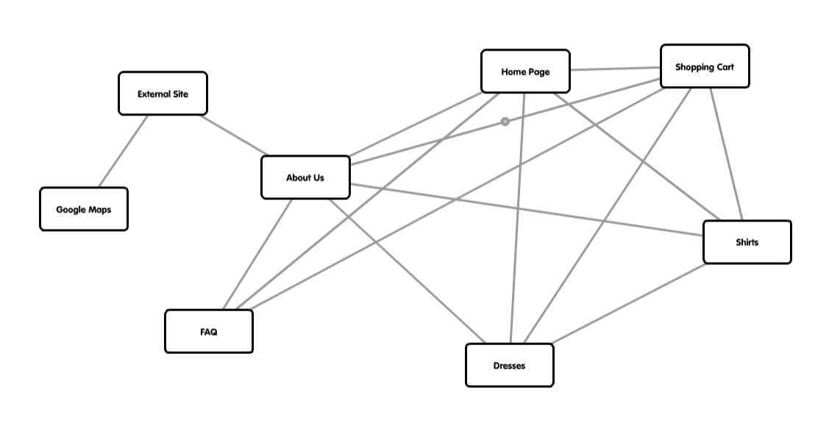

**Storyboard:**

**Home Page**

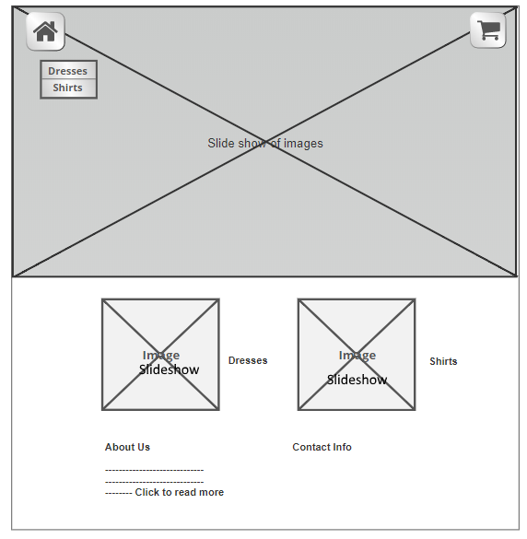

**About Us**

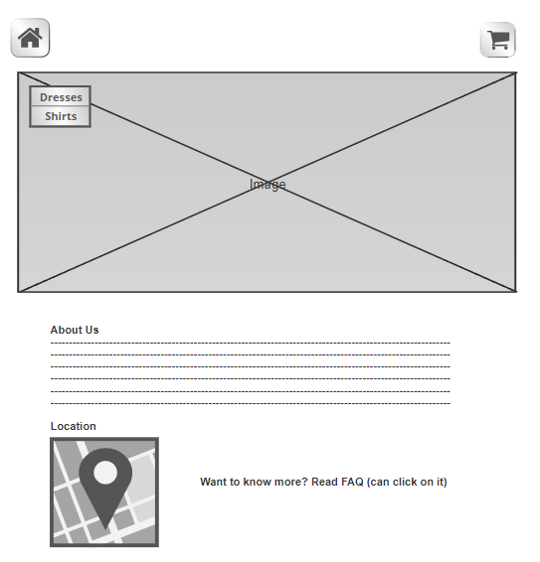

**FAQ**

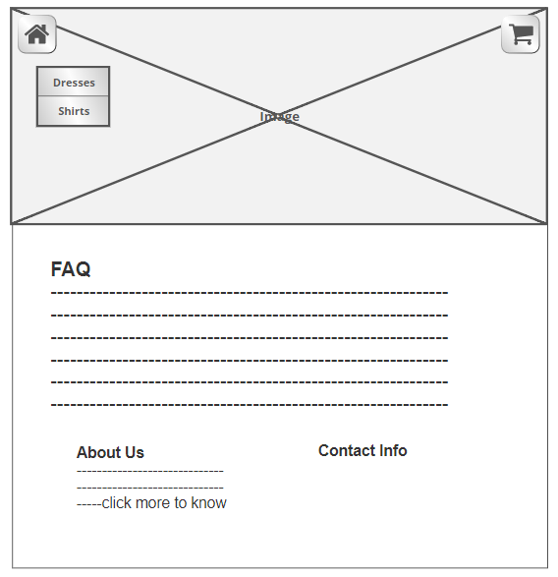

**Dresses/Shirts Page**

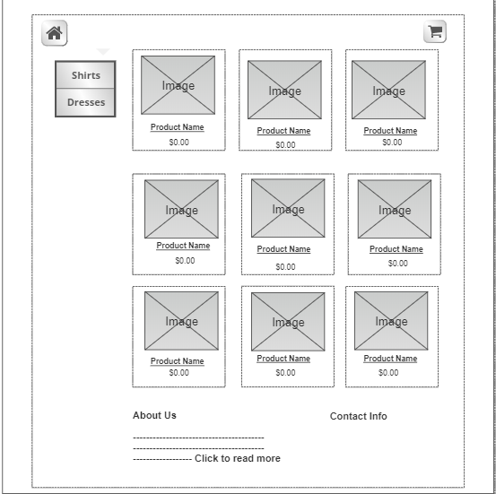

**Shopping Cart**

